Chapter 2 Forces and vectors
Short investigation 2.2: Forces in equilibrium
Name:
Aim
To explore the vector addition of concurrent coplanar forces that are in static equilibrium
Materials
2 × 10 Newton spring scales, suspensible masses (250 g, 500 g and 1 kg), 40–50 cm length of strong cord, easel, drawing board made up of a 600 mm × 900 mm sheet of 15 mm MDF, protractor, butcher’s paper, sticky tape, two nails, hammer, spirit level
Method
- Hammer the nails into the MDF near the top edge and about 55 cm apart. It does not matter if they are not the same distance from the top of the board. They should be firmly fixed, but avoid hammering them so deeply that they protrude through the back of the board.
- Place the board on the easel. If you can, clamp the board in such a way that it is as vertical as possible. Use the spirit level to help you in this.
- Sticky tape a sheet of butcher’s paper so that it covers most of the board.
- Calibrate the spring scales and hang one scale from each of the nails. Designate them as scale A and scale B.
- Tie one end of the cord to each of the scale hooks so that it hangs between them. Test that the knots do not slip.
- Hang the 250 g mass from the cord. Without moving the mass or the cord, trace the positions of the sections of cord between the weight and the spring scales and the weight itself onto the paper beneath. Also note the reading on each of the scales A and B.
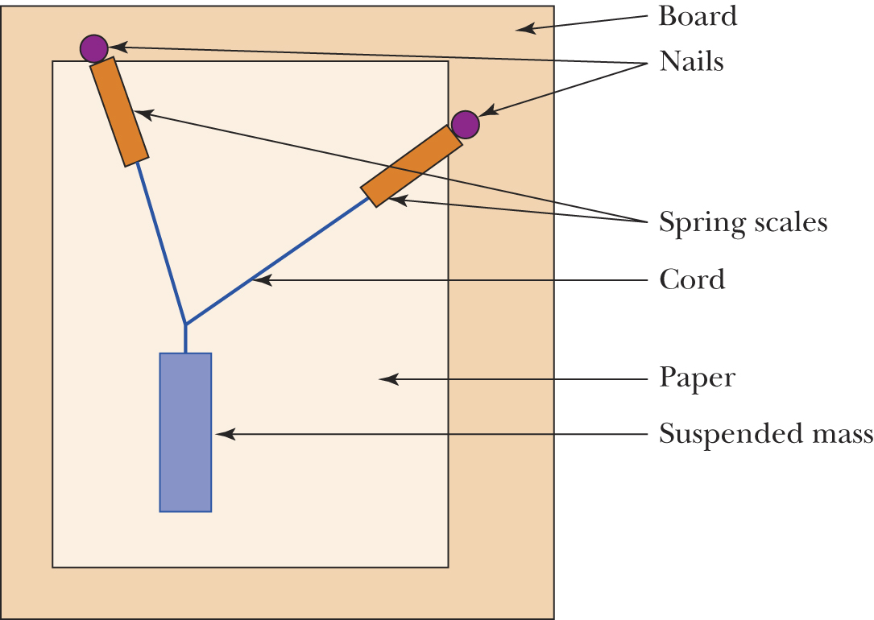

- Remove the paper from the board. Use a protractor to measure the angles θ_{A}, θ_{B} and θ_{w} as shown in the figure below.
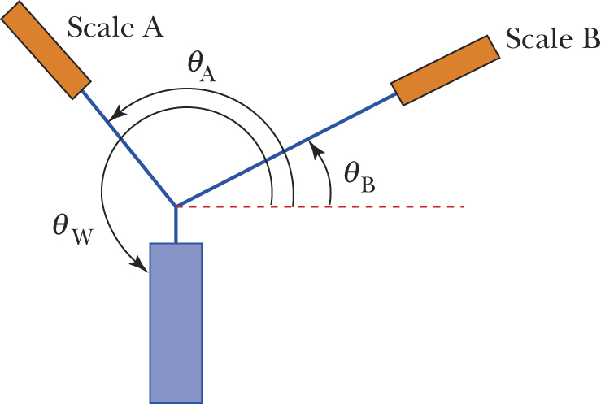
- Enter the values obtained into table 2.2A.
- Calculate the weight of the 250 g mass by using the equation w = mg where g is equal to 9.8 m s^{–2}. Enter this value into table 2.2A.
- Repeat steps 6–9 for the 500 g and 1 kg masses.
Results
Table 2.2A
Mass  (g) | Weight  (N) | Scale A reading  (N) | Scale B reading  (N) | θ_{A} | θ_{B} | θ_{w}
250
500
1000
Analysing the results
- (a) In the space below, use the values in columns 3, 4, 5 and 6 to draw scale diagrams …….of the vector addition of the tension forces A and B for each of the three masses. In …….each case, determine the value and direction of the equilibrant vector E.
  - Enter the values of the equilibrant E for each of the masses in table 2.2B below.
Table 2.2B
Mass (g) | Equilibrant
Mass (g) | Magnitude of E | θ_{E}

- In theory, your equilibrant values will be equal to those for your weight vector, i.e. in each case E = w and θ_{E} = θ_{w}. This is because, as the system is in static equilibrium, the vectors representing the tension in the two parts of the cord and the weight will sum to give a resultant of zero. How well did your determined values for the equilibrant compare with the values for the weight?
- If there was some discrepancy between the values, give possible explanations.
- The angle of the weight vector should have been such that it was pointing vertically downwards in every case, i.e. θ_{w} = 270°. Was this the case in your investigation? If not, give reasons why this may not have happened.
- In the aim, we stated that the forces we would examine were coplanar and concurrent. What do these terms mean, and were these conditions met in this investigation?
Conclusion
What have we found out in this investigation?
Notes:

